Minimum Spanning Tree Example
Graph theory is one of the branches in mathematics. In which it deals with graph, vertices, edges etc. A graph is a group of vertices and edges. In a graph the vertex is a point and the edge is a line joined by two vertices. Spanning tree is a tree in which it should contain all the vertices of a graph G. A graph has more than one spanning tree. Minimum spanning tree can be identified with the help of weighted graph. A spanning tree which has minimum weight is known as Minimum Spanning Tree (MST).

Example Problems (with solutions) – Minimum Spanning Tree:
Example 1 : Draw a spanning tree for a following graph G:
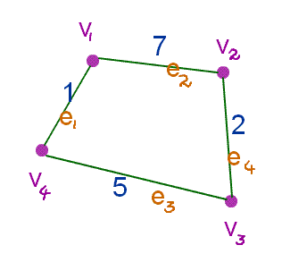
Solution:
- The given graph has a set of vertices and edges.
- G = (V, E)
- The set of vertices are V = {v1, v2, v3, v4}.
- The set of edges are E = {e1, e2, e3, e4}.
- The spanning of a graph G should have the vertices as same set of vertices of a graph G.

Spanning tree 1:
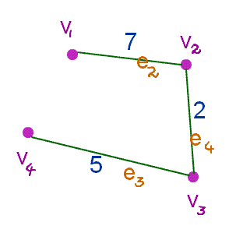
- The vertices of a spanning tree are V = {v1, v2, v3, v4}.
- The edges of a spanning tree are E = { e2, e3, e4}.
- The weight of this spanning tree is `=>` 7 + 5 + 2
`=>` 14

Spanning tree 2:
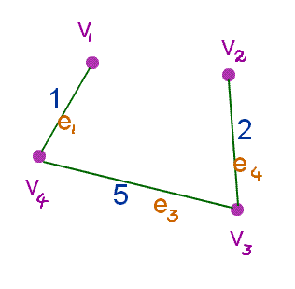
- The vertices of a spanning tree are V = {v1, v3, v4}.
- The edges of a spanning tree are E = {e1, e2, e3, e4}.
- The weight of this spanning tree is `=>` 1 + 5 + 2
`=>` 8
Spanning tree 3:
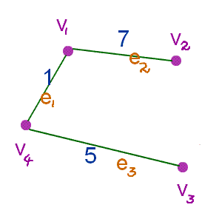
- The vertices of a spanning tree are V = {v1, v2, v3, v4}.
- The edges of a spanning tree are E = {e1, e2, e3 }.
- The weight of this spanning tree is `=>` 1 + 7 + 5
`=>` 13

Spanning tree 4:
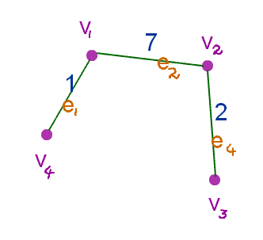
- The vertices of a spanning tree are V = {v1, v2, v3, v4}.
- The edges of a spanning tree are E = {e1, e2, e4}.
- The weight of this spanning tree is `=>` 1 + 7 + 2
`=>` 10
Here the spanning tree 2 has a minimum weight so that is a minimum spanning tree for a graph G.

Example 2: Draw a spanning tree for a following graph G
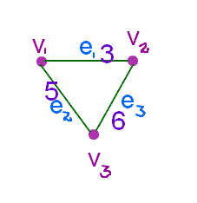
Solution:
- The given graph has a set of vertices and edges.
- G = (V, E)
- The set of vertices are V = {v1, v2, v3}.
- The set of edges are E = {e1, e2, e3}.
- The spanning of a graph G should have the vertices as same set of vertices of a graph G.
Spanning tree 1:
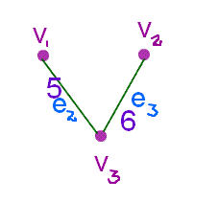
- The vertices of a spanning tree are V = {v1, v2, v3 }.
- The edges of a spanning tree are E = {e2, e3}.
- The weight of this spanning tree is `=>` 5 + 6
`=>` 11
Spanning tree 2:
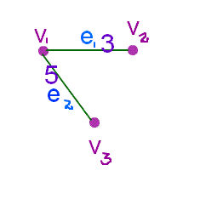
- The vertices of a spanning tree are V = {v1, v2, v3 }.
- The edges of a spanning tree are E = {e1, e2}.
- The weight of this spanning tree is `=>` 5 + 3
`=>` 8

Spanning tree 3:
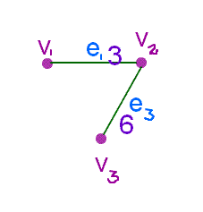
- The vertices of a spanning tree are V = {v1, v2, v3}
- The edges of a spanning tree are E = {e1, e3}.
- The weight of this spanning tree is `=>` 3 + 6
`=>` 9
Here the spanning tree 2 has a minimum weight so that is a minimum spanning tree for a graph G.


Kruskal's Algorithm Examples

Kruskal’s algorithms is one of the types of greedy algorithms which is used to solve a minimal spanning tree (MST) by choosing the best possible choice at each step and then, this decision leads to the best over all solution.
Here, we will learn about the elements of greedy algorithm, properties of kruskal's algorithm and examples.

First of all what is a Greedy Algorithm?
A greedy algorithm is an algorithm that follows the problem solving method of making the locally optimal choice at each stage with the hope of finding a global optimum. In many problems, a greedy strategy does not in general produce an optimal solution, but nonetheless a greedy method may yield locally optimal solutions that approximate a global optimal solution in a reasonable time.
For example, a greedy strategy for the traveling salesman problem* (which is of a high computational complexity) is the following heuristic: "At each stage visit an unvisited city nearest to the current city". This heuristic need not find a best solution, but terminates in a reasonable number of steps; finding an optimal solution typically requires unreasonably many steps. In mathematical optimization, greedy algorithms solve combinatorial problems having the properties of matrices.
*The Travelling Salesman Problem - The travelling salesman problem (TSP) asks the following question: Given a list of cities and the distances between each pair of cities, what is the shortest possible route that visits each city exactly once and returns to the origin city? (see: https://en.wikipedia.org/wiki/Travelling_salesman_problem)

Elements of Greedy Algorithm:
Greedy choice property states that a globally optimal solution is derived from a locally optimal (greedy) choice. And, when choices are made, the choice that looks the best in the given problem is chosen, without considering the results from sub problems.
Optimal substructures states that a problem has optimal substructure, if and only if, an optimal solution to the problem is made up of optimal solutions to its sub-problems. This property is important for greedy algorithms.
Greedy algorithms do not always yield the optimal solutions. But, still they provide the best possible solutions.
Thus, we have to form the optimization problem in such a way that, after a choice is made and there would be only one sub problem left to be solved. There is always an optimal solution for the problem that has been given to us which makes the greedy choice, such that the greedy choice is always safe.

After the greedy choice has been made, if we combine an optimal solution to the sub problem with that chosen greedy choice, we arrive at an optimal solution to the given problem.

Properties of Kruskal's Algorithm:
- It works not only with directed graphs.
- It works with weighted and not weighted graphs. But, is more interesting, when edges are weighted.
- It is a type of greedy algorithm that produces optimal solutions of the MST.

Steps of Kruskal's Algorithm:
The main steps of the Kruskal's Algorithm are as follows:
- Arrange the edges by weight: least weight first and heaviest last.
- Choose the lightest not examined edge from the diagram. Add this chosen edge to the tree, only if doing so will not make a cycle.
- Stop the process whenever n - 1 edges have been added to the tree.

Worked Examples
Question 1: Solve the following by applying Kruskal's Algorithm.
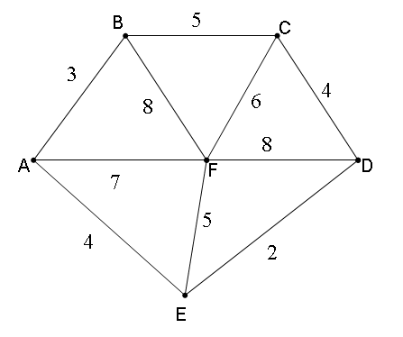
Solution: The list of edges in order of their weights or sizes would be as follows:
Edge Weight Edge Weight
ED 2 EF 5
AB 3 CF 6
AE 4 AF 7
CD 4 BF 8
BC 5 CF 6
The various iterations would be as follows:
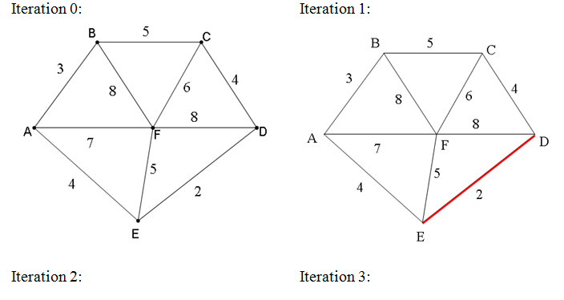
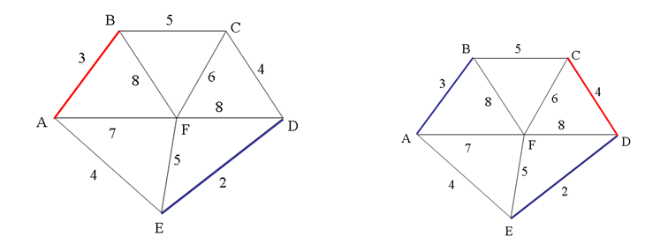
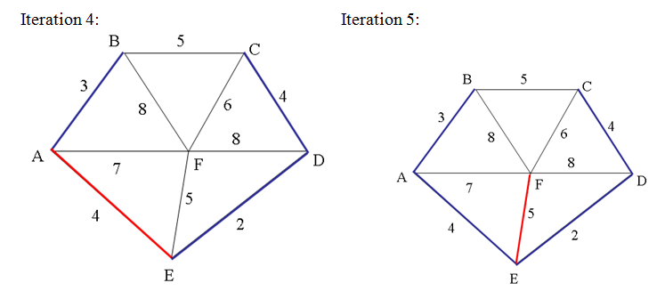
All the vertices have been connected now, hence, the last iteration number 5, gives us the optimal solution, and the minimum length would be the sum of all weights given to these edges, as 2 + 3 + 4 + 4 + 5 = 18 is the length of the shortest path by applying Kruskal's Algorithm.
That is, the solution is
ED 2
AB 3
CD 4
AE 4
EF 5,
with Total weight of tree equal to 18

Question 2: Find the optimal path of the following minimal spanning tree by applying Kruskal's Algorithm.
Solution: The optimal paths are drawn as bold lines representing the optimal paths of the spanning tree, which constitutes the minimum length of the shortest path, as shown below:

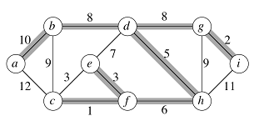

Kruskal’s Algorithm in Two Minutes – Review and Example
https://www.youtube.com/watch?v=71UQH7Pr9kU

Prim’s Algorithm Examples

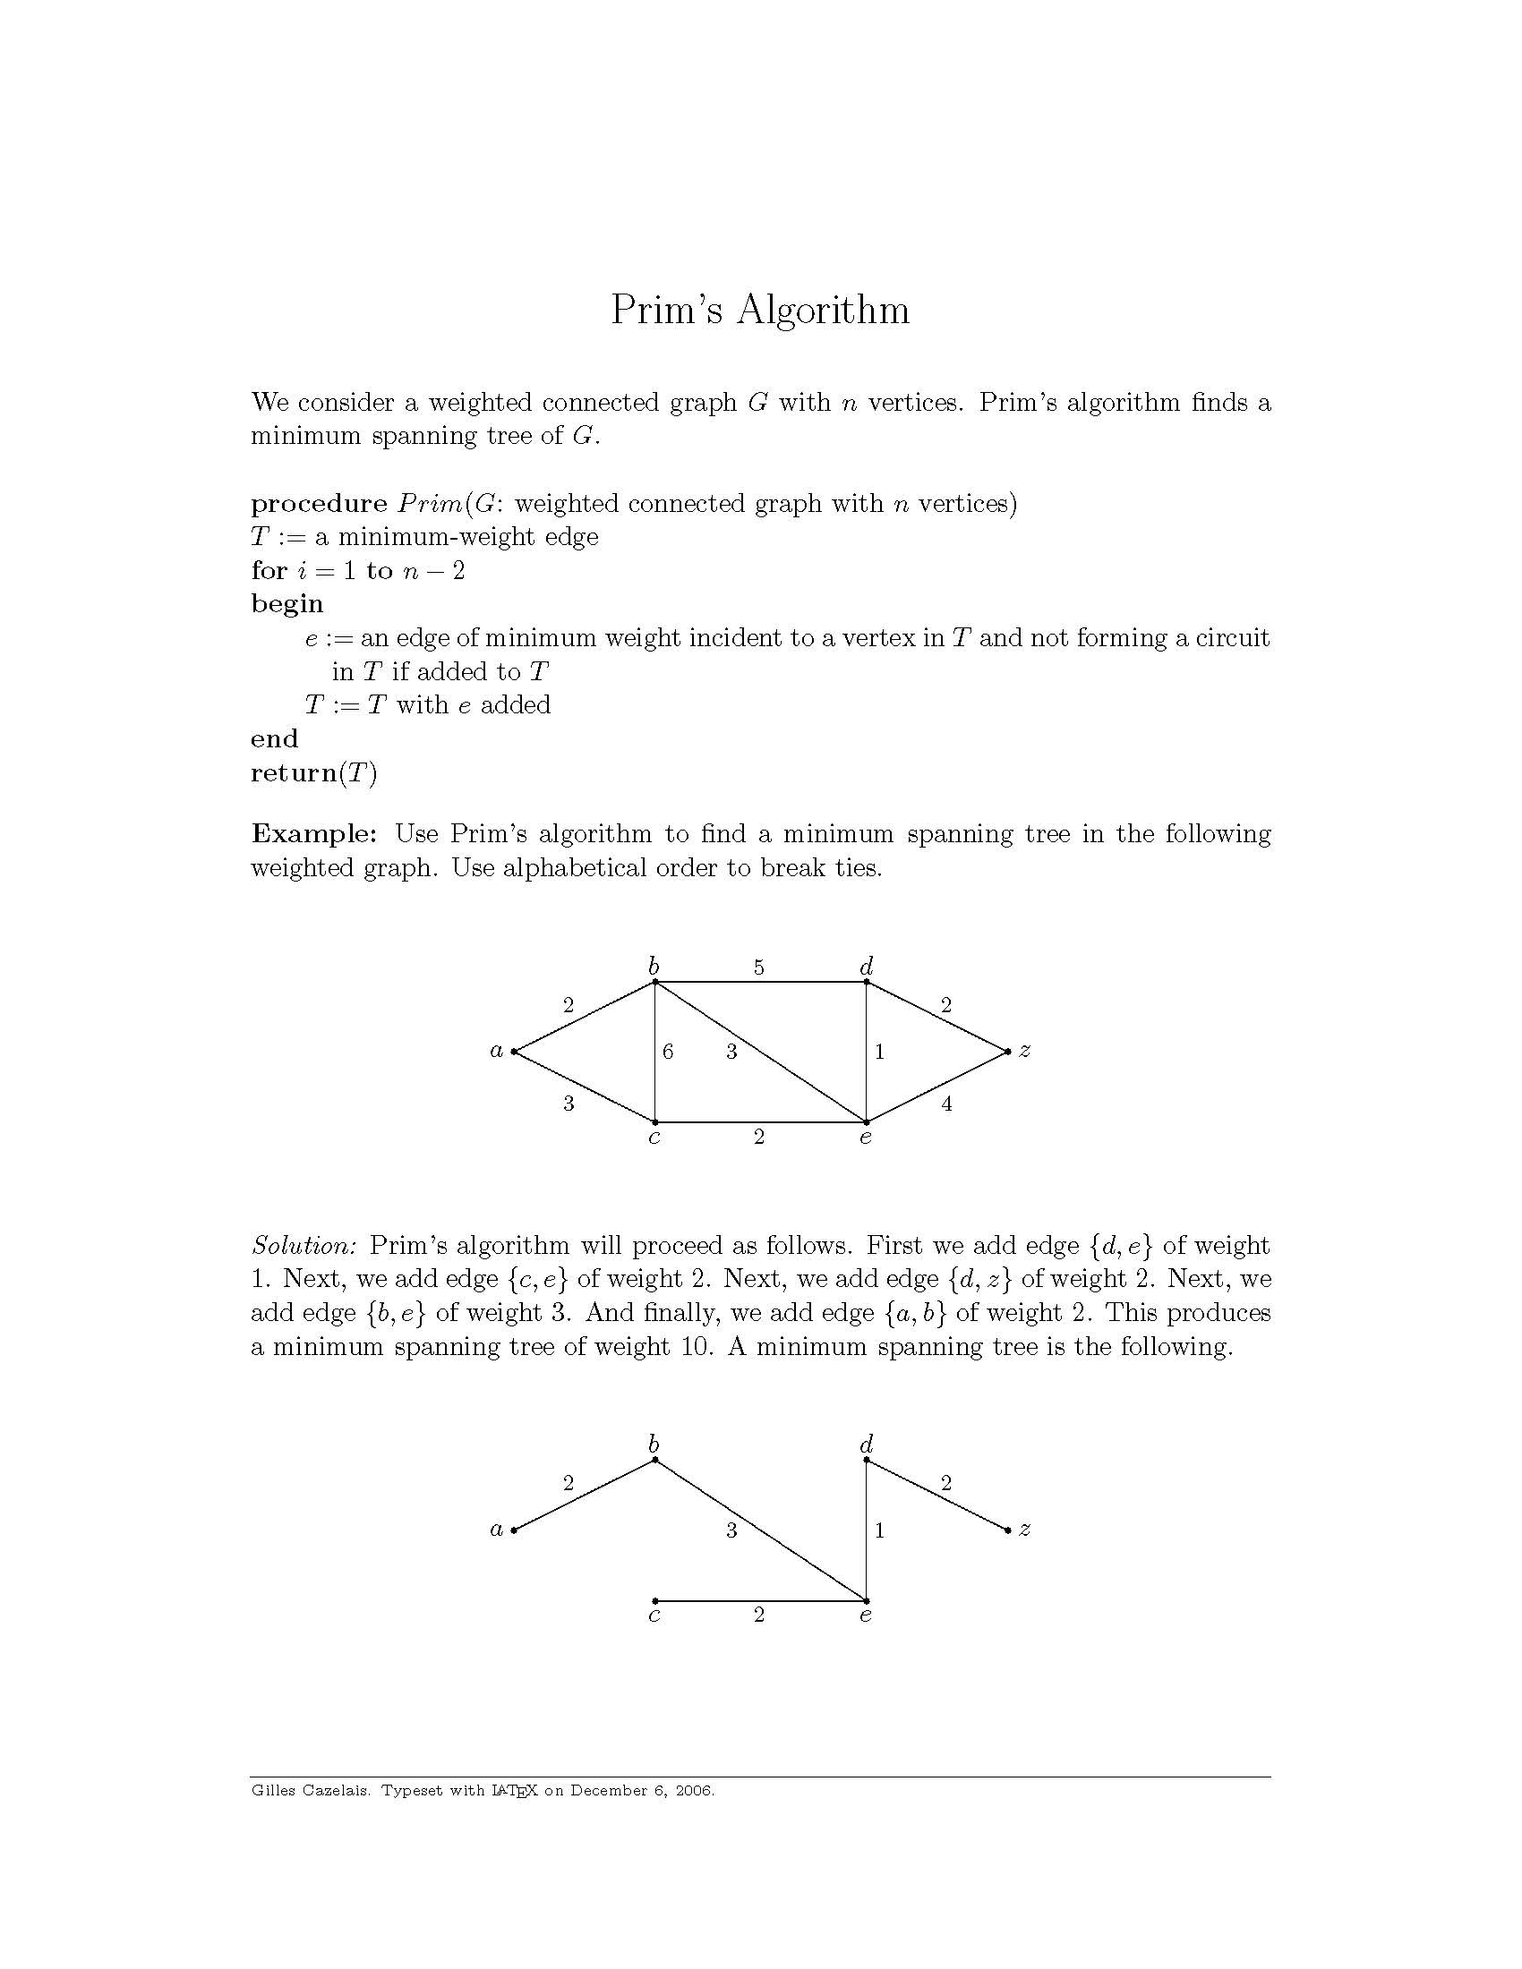
Minimum Spanning Tree:
A Minimum Spanning Tree (MST) is a kind of a sub graph of an undirected graph in which, the sub graph spans or includes all the nodes has a minimum total edge weight.
To solve the problem by a prim's algorithm, all we need is to find a spanning tree of minimum length, where a spanning tree is a tree that connects all the vertices together and a minimum spanning tree is a spanning tree of minimum length.
Steps of Prim's Algorithm:
The following are the main 3 steps of the Prim's Algorithm:
- Begin with any vertex which you think would be suitable and add it to the tree.
- Find an edge that connects any vertex in the tree to any vertex that is not in the tree. Note that, we don't have to form cycles.
- Stop when n - 1 edges have been added to the tree.

Properties of Prim's Algorithm:
Prim's Algorithm has the following properties:
- The edges in the subset of some minimum spanning tree always form a single tree.
- It grows the tree until it spans all the vertices of the graph.
- An edge is added to the tree, at every step, that crosses a cut if its weight is the minimum of any edge crossing the cut, connecting it to a vertex of the graph.
Similarity of Prim's Algorithm with Kruskal's Algorithm:
Prim's Algorithm is quite similar to Kruskal's with one big difference which is as follows:
The tree that we are growing or making it further ALWAYS stays connected. Whereas, in Kruskal's algorithm, we can add an edge to our growing tree that wasn't connected to the rest of it. But, here in Prim's Algorithm, we can't do it.

Solved Example
Question: Solve the following by applying Prim's Algorithm.
Solution:By applying Prim's Algorithm, we will find the following iterations:
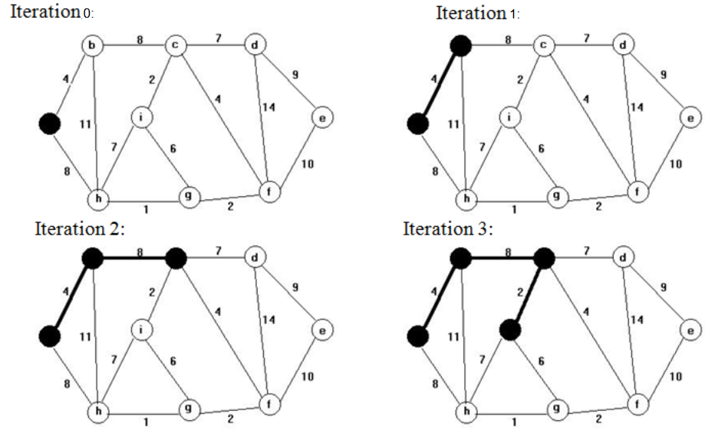
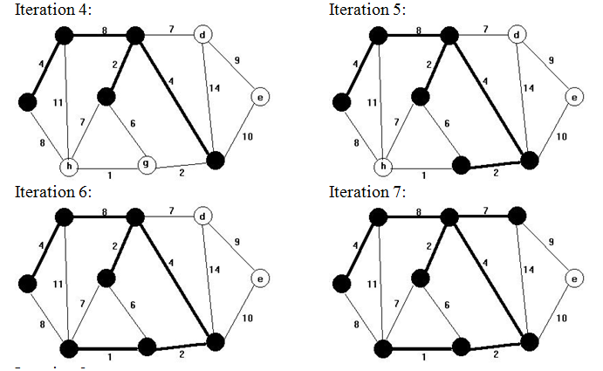
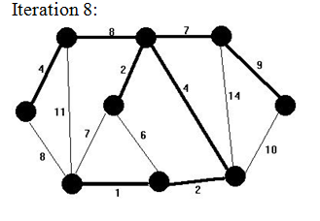
Here, the last iteration number 8 represents the optimal solution of the problem, given by the bold dark black lines, which gives us the minimum length of the path. And, the length would be calculated by adding the numbers written on optimal path. That is, 4 + 8 + 7 + 9 + 2 + 4 + 2 + 1 = 37 is the minimum length.
Prim’s Algorithm in Two Minutes – Review and Example
https://www.youtube.com/watch?v=cplfcGZmX7I
- Kruskal's algorithm for solving the Minimum Spanning Tree Problem is
  - an optimal and efficient algorithm
  - an optimal and inefficient algorithm
  - an approximate and efficient algorithm
  - an approximate and inefficient algorithm
  - None of these

- Which of the following algorithm(s) is(are) optimal and efficient?
  - Cheapest Link algorithm for solving the TSP
  - The brute force algorithm for solving the TSP
  - Prim's algorithm for solving the MST problem
  - a and c
  - None of the above

- Which of the following are true of a tree?
  - any graph that is connected and has bridges
  - any graph that is connected and has no bridges
  - any graph that is connected and has no circuits
  - any graph that has no circuits
  - None of the above

- If a tree has 98 edges, then the number of its vertices is:
  - 97
  - 99
  - 100
  - 98
  - None of these

- Suppose a tree T has 9 vertices, then
  - it has one bridge
  - it can have any number of bridges
  - it has 9 bridges
  - it has no bridges
  - None of the above – tree has all edges and hence all are bridges 8

- Prim's algorithm applied to in Figure 1, starting at C yields the following sequence of edges:
    - CD, CB, CA
    - CD, CA, CB
    - CA, CD, CB
    - CA, CB, CD
    - None of the above
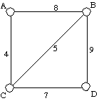
Figure 1
- For finding minimum spanning trees, Kruskal's algorithm is:
  - efficient
  - exact
  - greedy
  - a & b
  - a & c
  - b & c
  - all of the above
  - none of the above

- Every graph with N vertices and N - 1 edges is a tree.
  - True
  - False

- Use Kruskal's algorithm to find a minimum spanning tree of the given graph below. Draw the resulting spanning tree and list the edges in the order they are picked by Kruskal's algorithm.
